Giezhia Mye B. Diaz BsCpE 4A October 30, 2025

Project Sentiment Analysis (Tensorflow NLP Transfer Learning with GloVe Embeddings)
Progress Report
Objectives:
- Develop a sentiment analysis using pre-trained GloVe.
- Build a FastAPI-based server where the sentiment analysis will be deployed for real-time text sentiment classification.
- Make a webpage with chatbox that connects to the server and the model.

Tasks Made:
Model Development:
- Set-up and configuration of tensorflow, tensorflow-datasets, flask, and scikit-learn
- Created directories for the embeddings, model_glove, and web.
- GloVe integration and vectorization.

Frontend (Webpage with ChatBox):
- Designed HTML and CSS chat box.
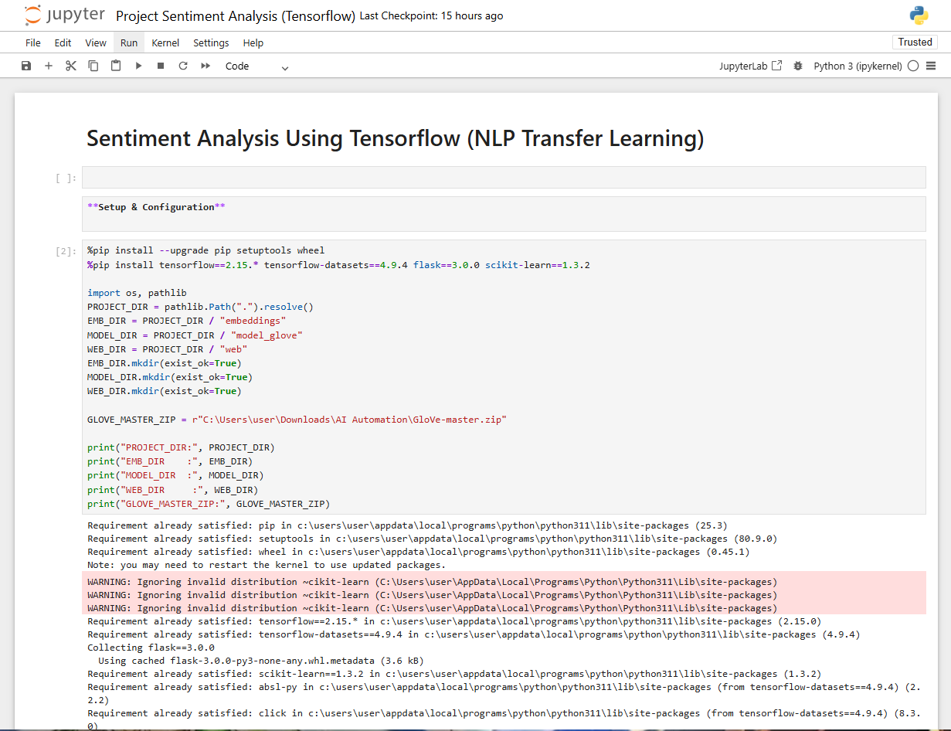
Images:
